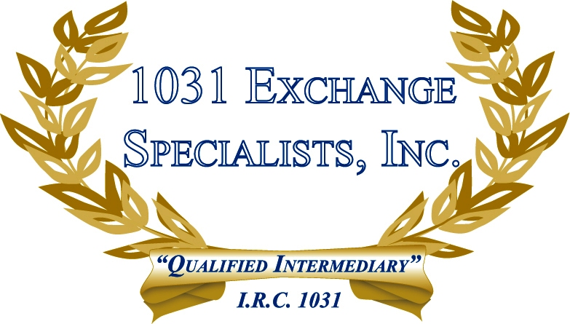

BUSINESS SWAP: In a "Business Swap", the IRS ruled that the assets of a business may not be combined and exchanged in a 1031 as a "single" asset, but must be analyzed on an asset-by-asset basis, like-groups, or like-classes.

For additional information, please call or email us at:
Local: 609-398-1031 • Toll free: 877-513-1031 info@1031ESI.com

