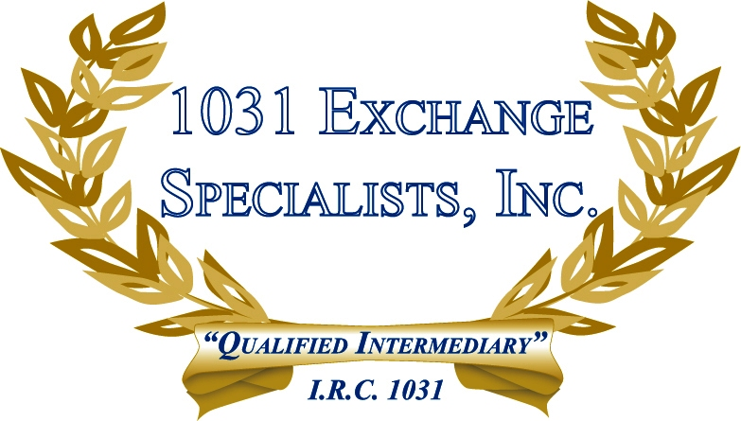

COLLECTIBLES: Collectibles, such as art, antiques, gems, stamps, coins, gold, wine, may be exchanged tax-free in a 1031 EXCHANGE if held for investment and not personal use. Otherwise, the taxpayer may be subject to a federal capital gains rate of 28% on the sale of Collectibles.

For additional information, please call or email us at:
Local: 609-398-1031 • Toll free: 877-513-1031 info@1031ESI.com

