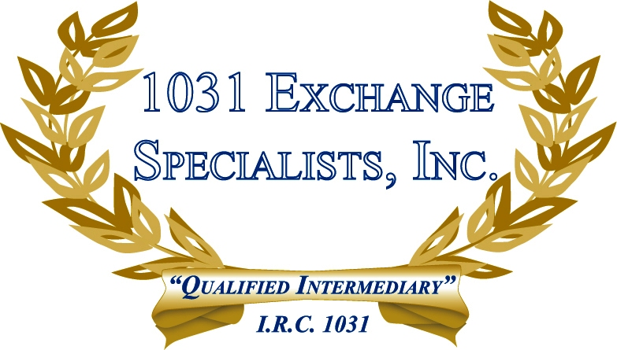

ITEMS TO CONSIDER WHEN SELLING YOUR BUSINESS: When negotiating a contract of sale for a motel, hotel, B&B, restaurant, liquor store, etc., be aware that the real estate, furniture & fixtures, goodwill, customer lists, inventory, licenses, etc. all have different tax consequences affecting the Buyer & Seller, especially if structuring a 1031 EXCHANGE.

For additional information, please call or email us at:
Local: 609-398-1031 • Toll free: 877-513-1031 info@1031ESI.com

