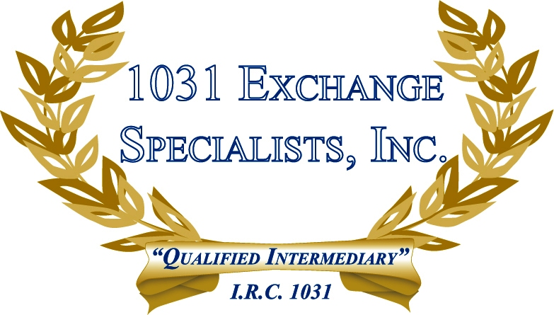

LAWS GOVERNING QUALIFIED INTERMEDIARIES: Qualified Intermediary in a 1031 EXCHANGE can generally conduct business throughout the U.S. and some territories outside the continental U.S. Certain states (CA, NV,WA, CO & ID) have enacted laws governing QI's considered "doing business" in the state.

For additional information, please call or email us at:
Local: 609-398-1031 • Toll free: 877-513-1031 info@1031ESI.com

