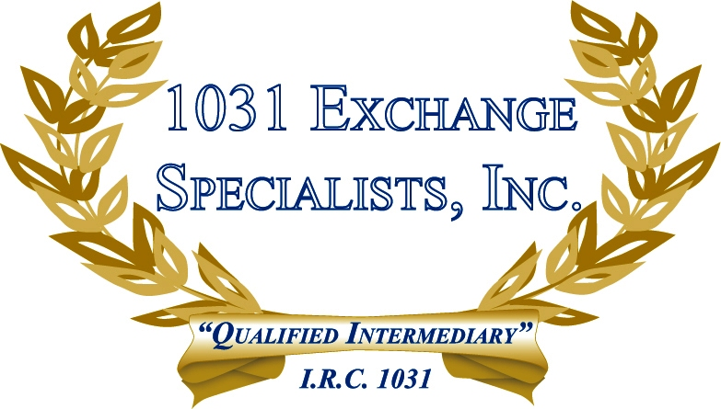

EXCHANGE REAL ESTATE, PERSONAL PROPERTY, & INTANGIBLES: 1031 EXCHANGES are not just for real estate. Personal property and some intangibles, such as cars, planes, boats, copyrights, liquor licenses, horses, and cattle are just some of the items that can avoid large taxable gains thru a 1031 EXCHANGE.

For additional information, please call or email us at:
Local: 609-398-1031 • Toll free: 877-513-1031 info@1031ESI.com

