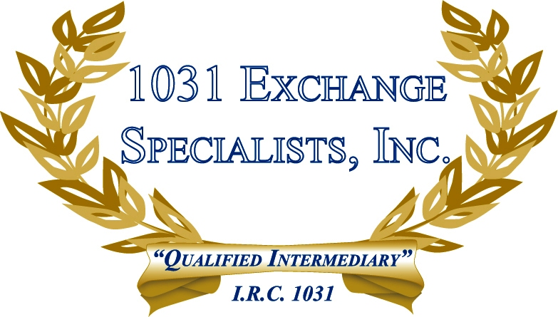

PERSONAL PROPERTY ASSET CLASS: In a 1031 Personal Property Exchange, the IRS ruled that properties can still be "like-kind" even if classified in different general asset classes, as those differences may not be in nature and character, but merely in grade and quality.

For additional information, please call or email us at:
Local: 609-398-1031 • Toll free: 877-513-1031 info@1031ESI.com

