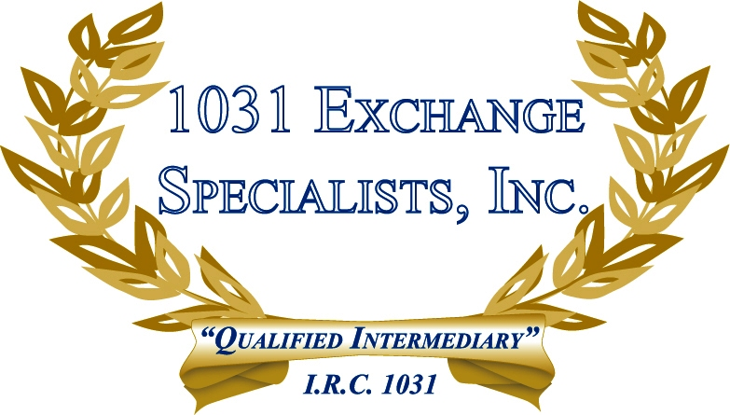

REPLACEMENT PROPERTY OWNED BY TAXPAYER: Property currently owned by a taxpayer or previously owned by the taxpayer within 180 days of commencing a 1031 EXCHANGE, does not qualify as "like-kind" replacement property.

For additional information, please call or email us at:
Local: 609-398-1031 • Toll free: 877-513-1031 info@1031ESI.com

